Dharmendrasinhji Arts College, Rajkot
UDISHA
COMPREHENSIVE REPORT

YEAR - 2021-22

Principal: Prof. Arunendrasinh Rathore
UDISHA Co-ordinator: Dr. Krishna Daiya
Committee Members: Dr. Jignesh Upadhyay, Dr. Jasmina Sharda, Dr. Harshida Jagodadiya, Dr. Kalyani Raval, Ms. Hina Parmar

UDISHA
(Universal Developmentof Integrated employability Skills through Higher education Agencies)
- UDISHA is a placement initiative where students directly connect to various employers to improve their employability skills.
- UDISHA works as a communication pathway between Employer and Job Seekers. For this, college students are trained for soft skills and communication skills.
- UDISHA initiative under extension at KCG is trying to develop skills among the youth of Gujarat State in order to make them employable and develop their personality.

Activities by UDISHA Committee

  - Expert Lectures on the following topics:
1) Basic English
2) Reading Skills
3) Positive Attitude
4) Interpersonal Skills
5) Interview Skills
6) CV Writing

UDISHA
LECTURE
SERIES

The resource persons from various colleges had been invited and remuneration paid as per the guidelines.
Here are some moments captured from the Lecture Series:
Expert Talk 1
Dr. Purvi Upadhyay (14/08/2021)
Topics: Basic English & CV Writing

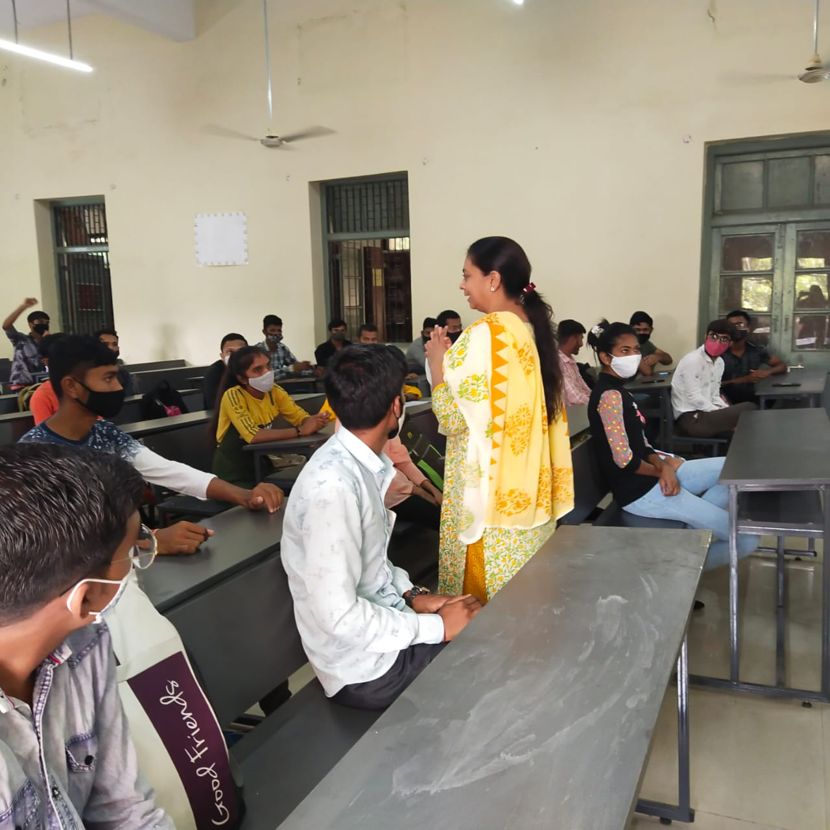

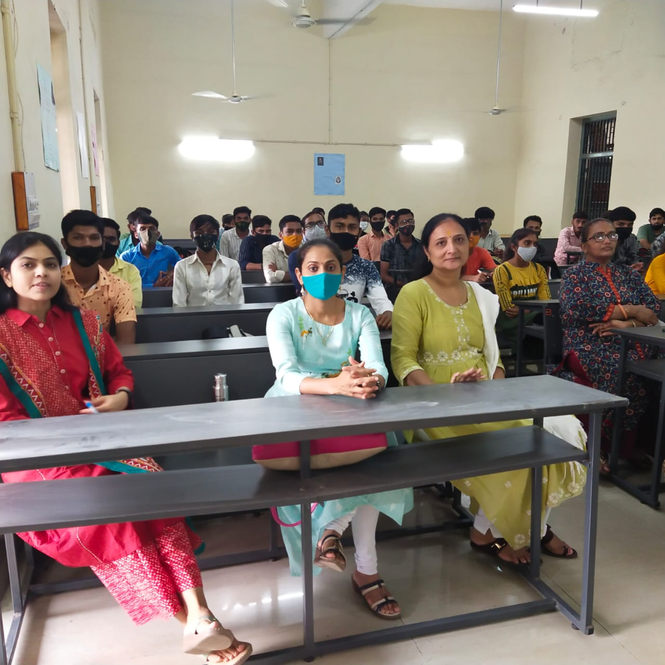

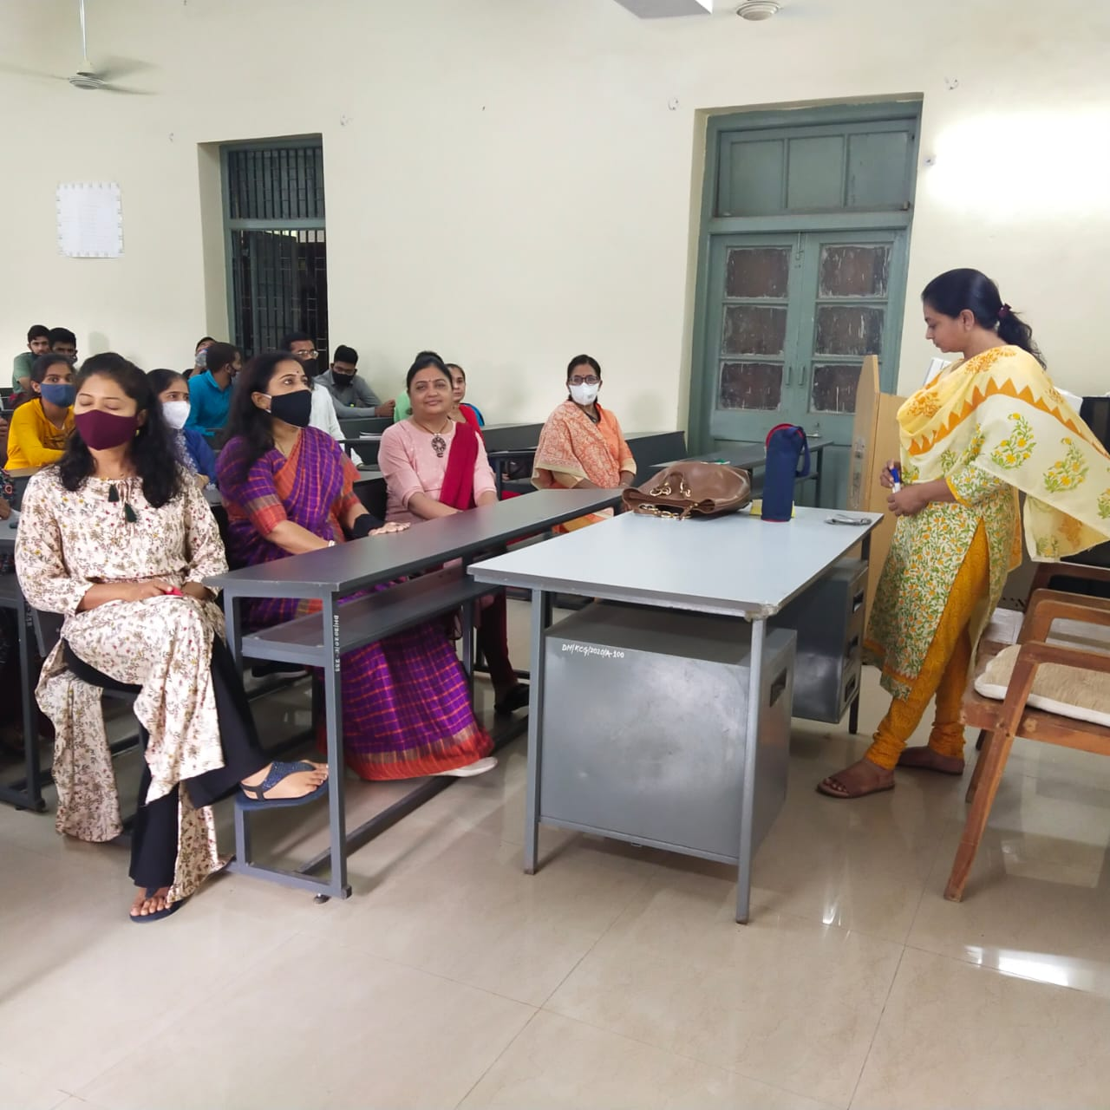

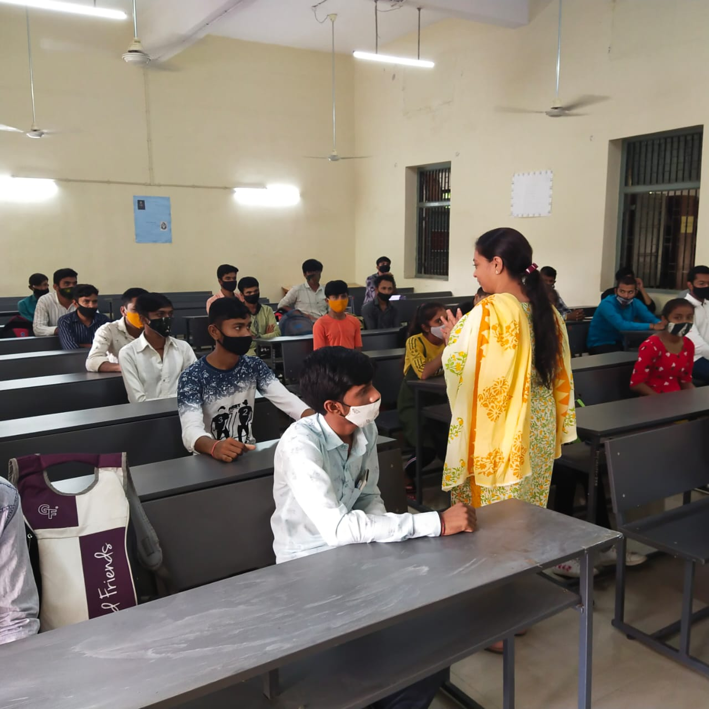
Expert Talk 2
Dr. Jiten Udhas (17/08/2021)
Topics: Basic English & Interview Skills

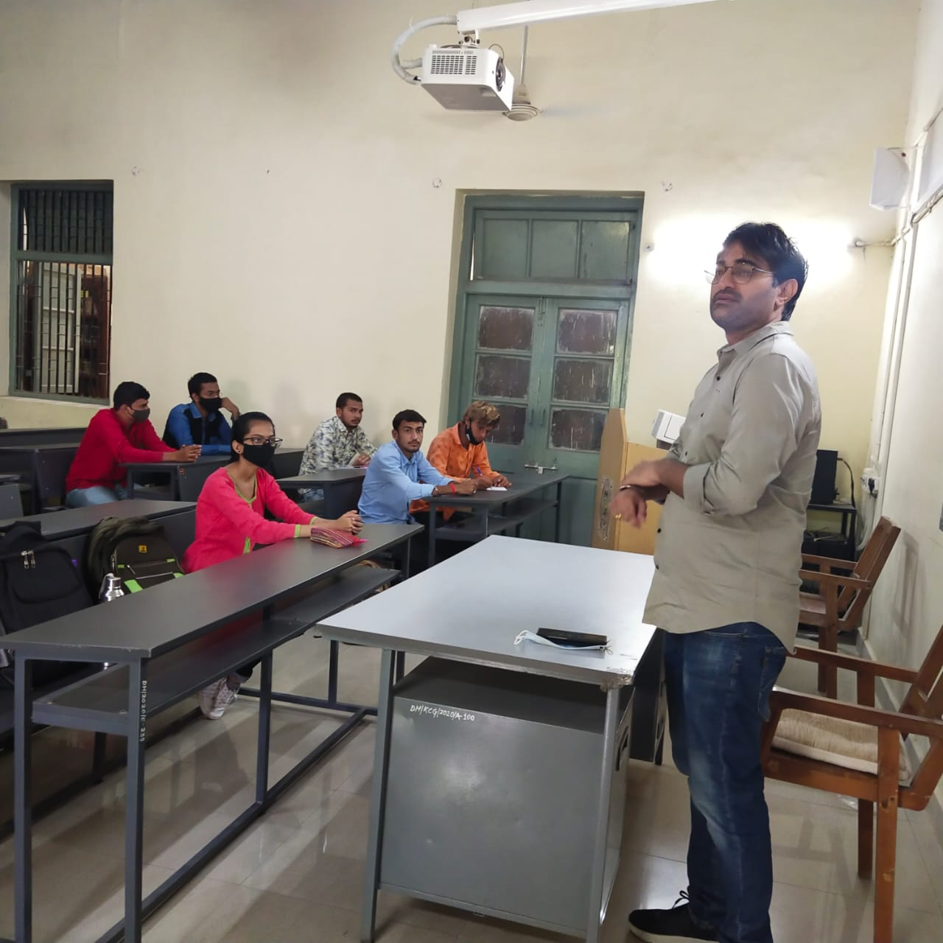

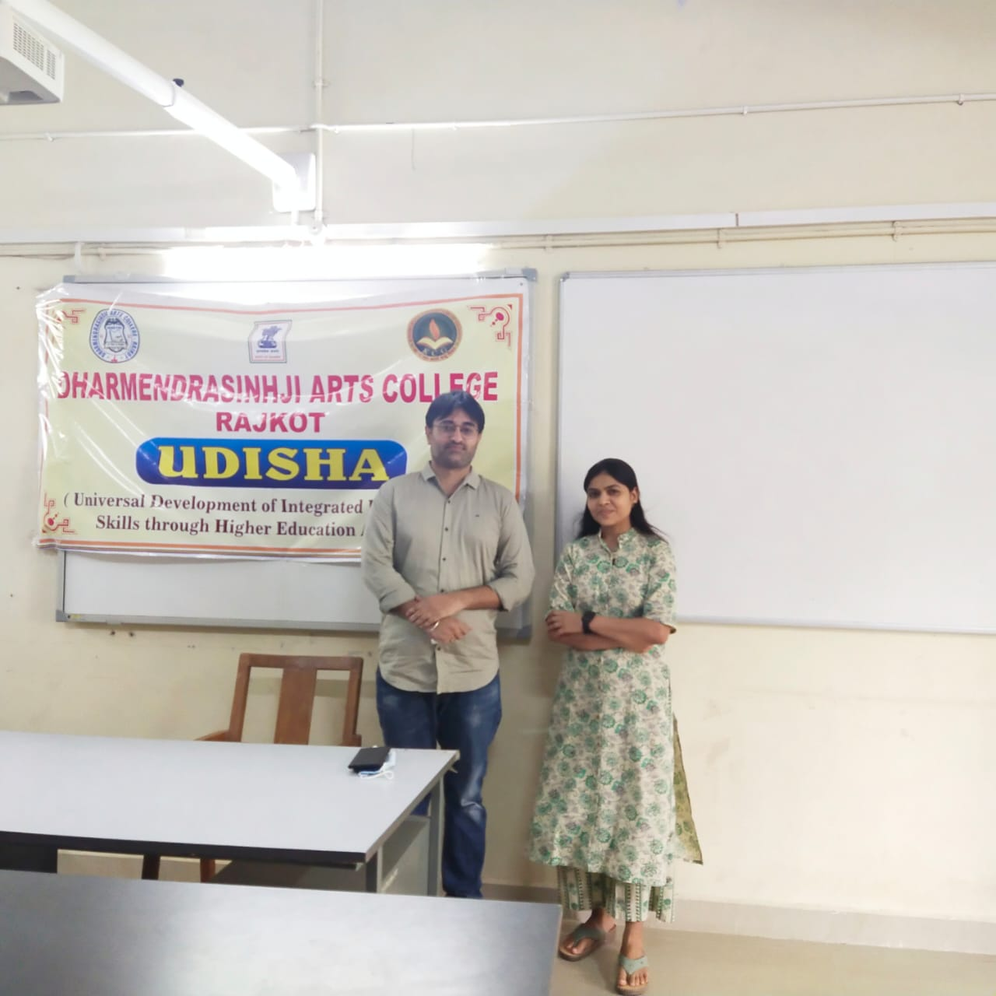

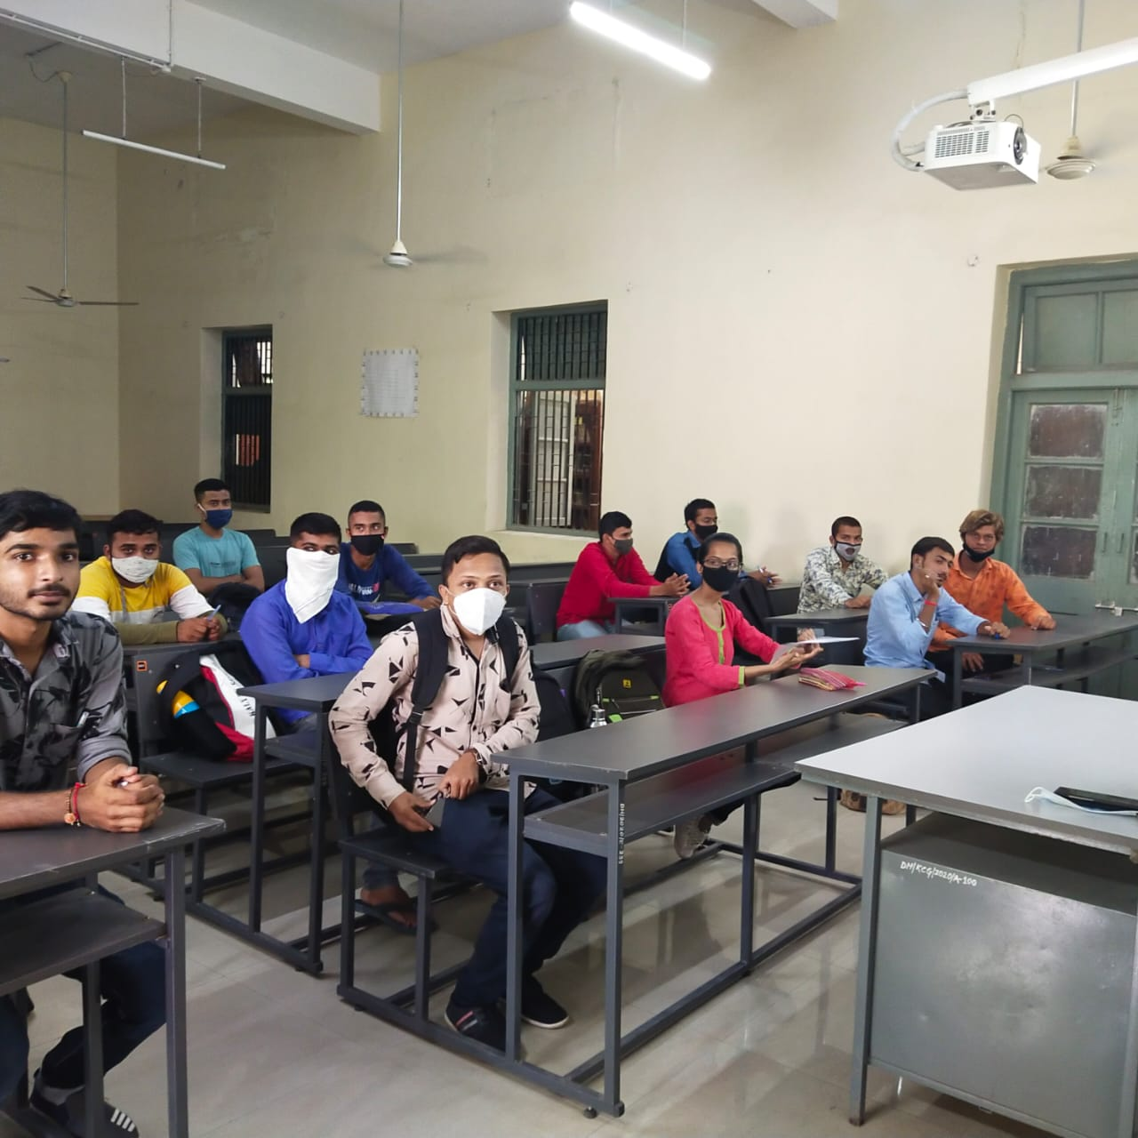

Expert Talk 3
Mr. Hiral Mody (16/09/2021)
Topics: Positive Attitude & Interpersonal Skills

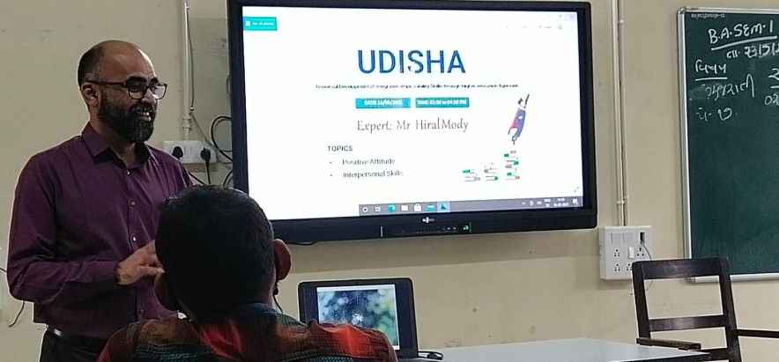

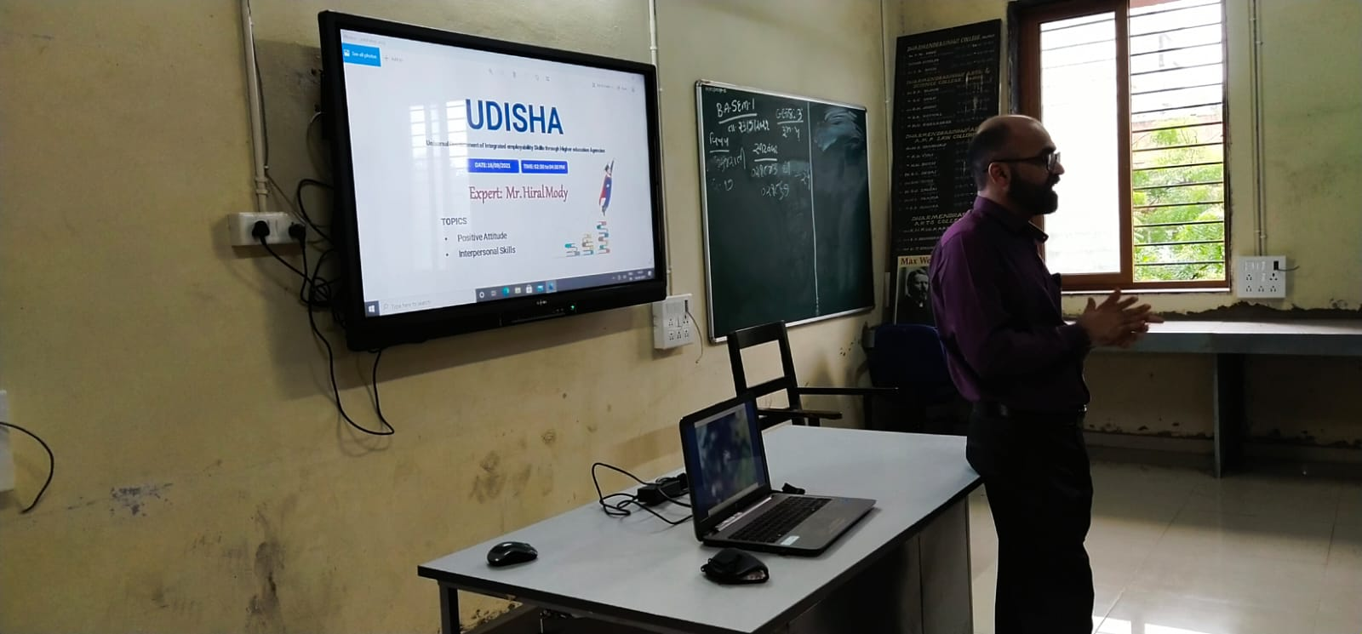

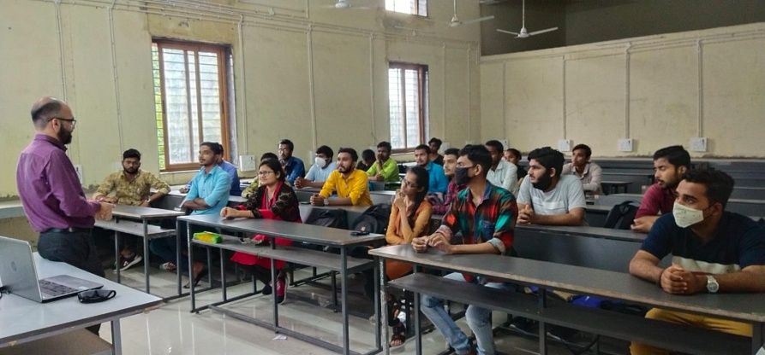

Expert Talk 4
Dr. Raviraj Raval (17/09/2021)
Topics: Reading Skills & Interpersonal Skills

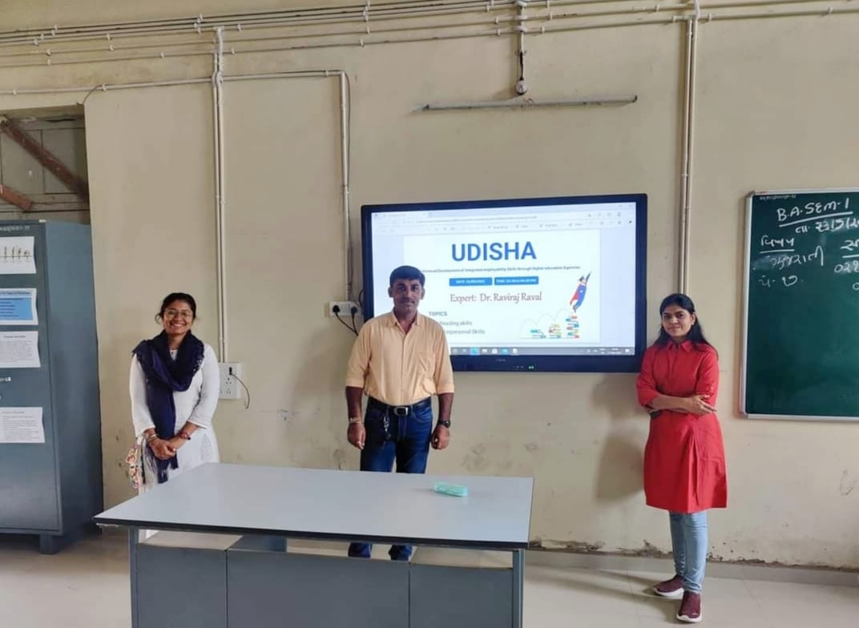

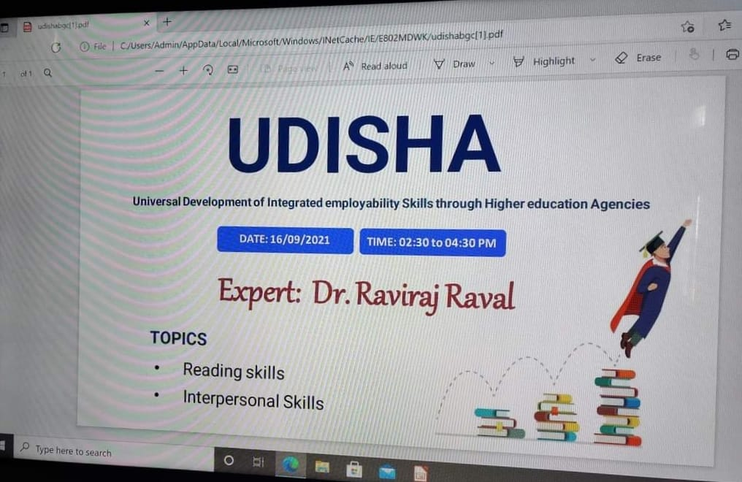

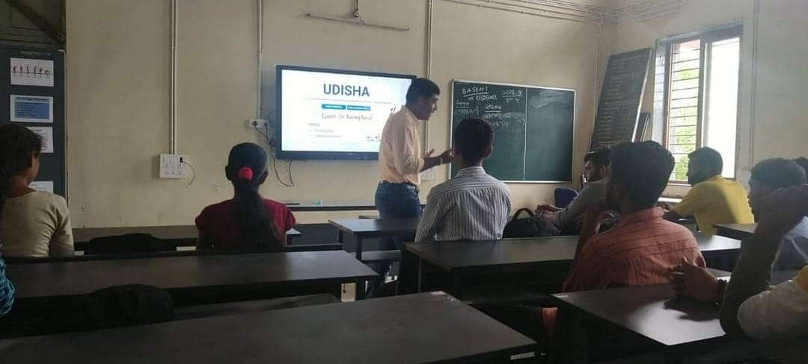

Expert Talk 5
Dr Deepak Mashru (23/09/2021)
Topics: CV Writins & Interview Skills

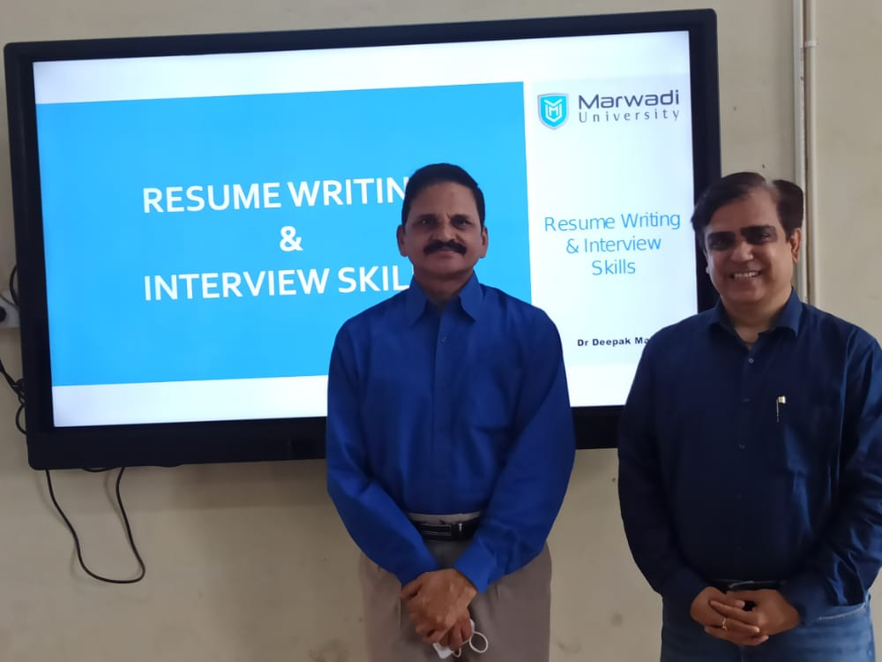

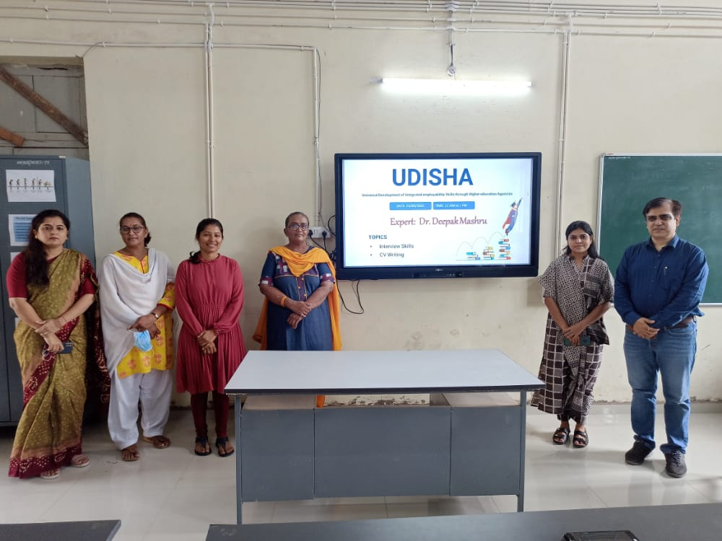

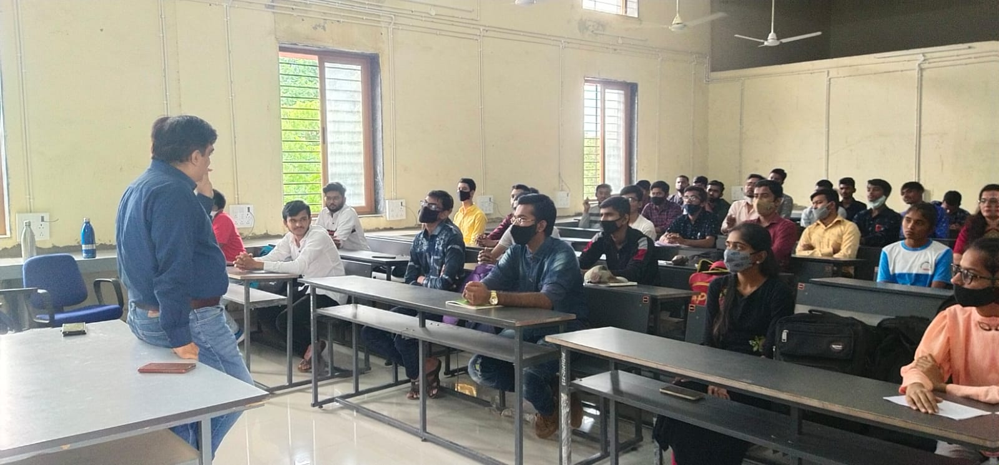

Expert Talk 6
Dr. Karansinh Rathod (25/09/2021)
Topics: Basic English & Interview Skills
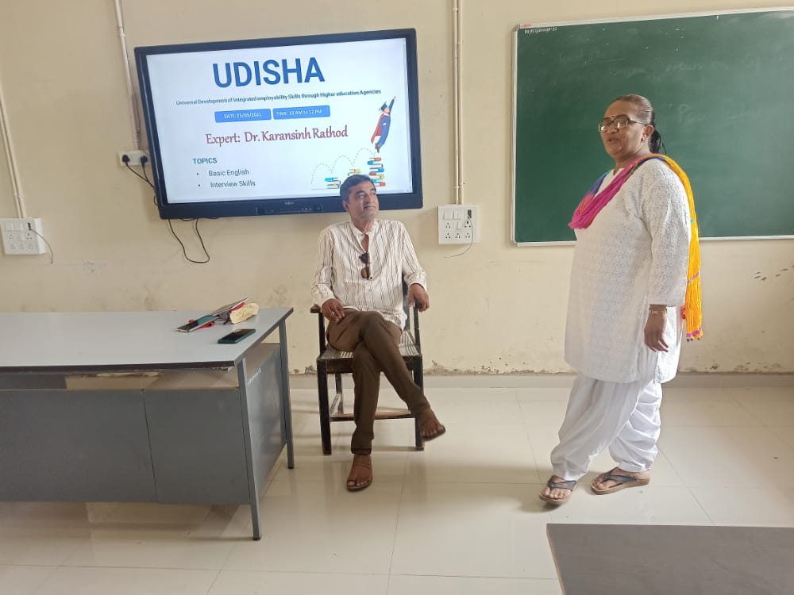
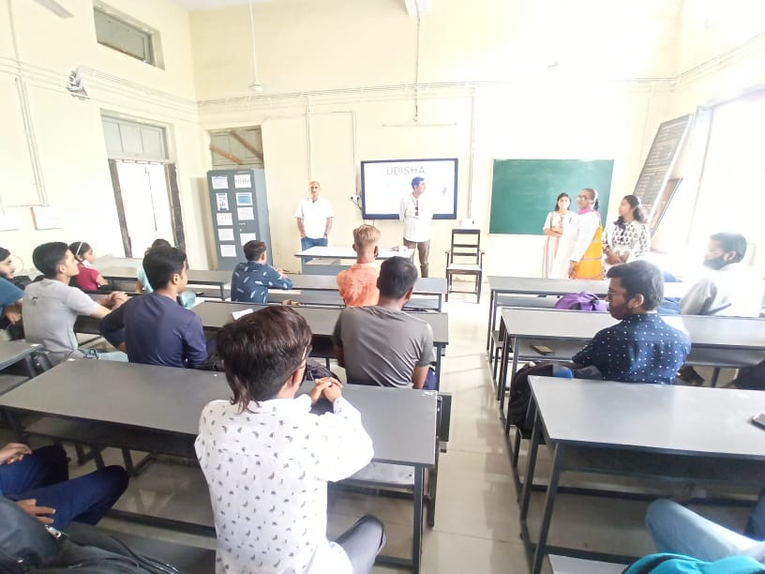

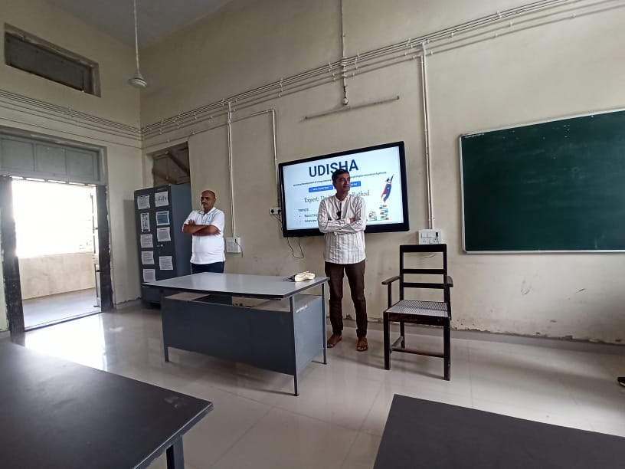

Expert Talk 7
Dr. Archana Dubey (29/09/2021)
Topics: Basic English & Interview Skills

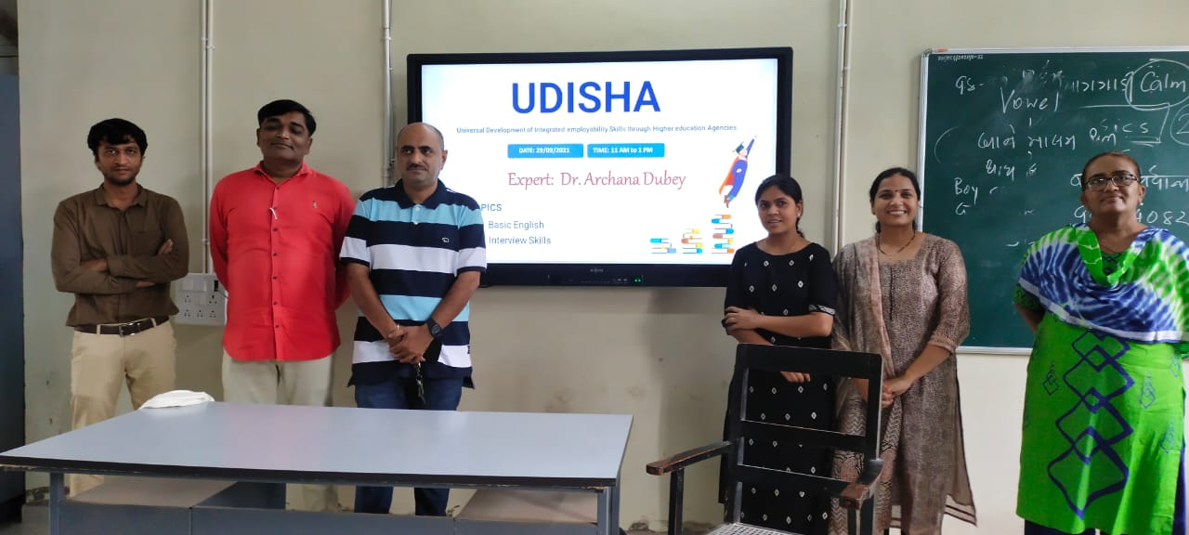

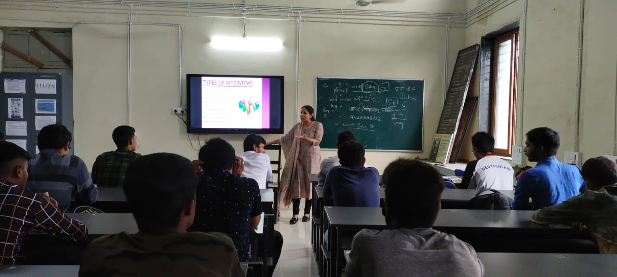

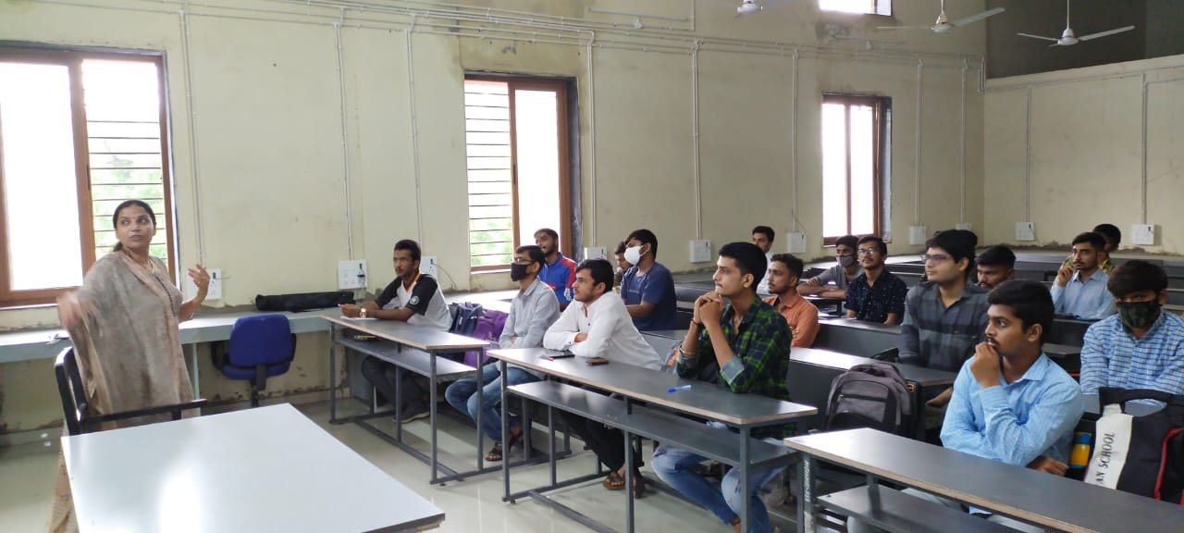

Expert Talk 8
Dr. Dilip Kataliya (04/10/2021)
Topics: Basic English & Reading Skills

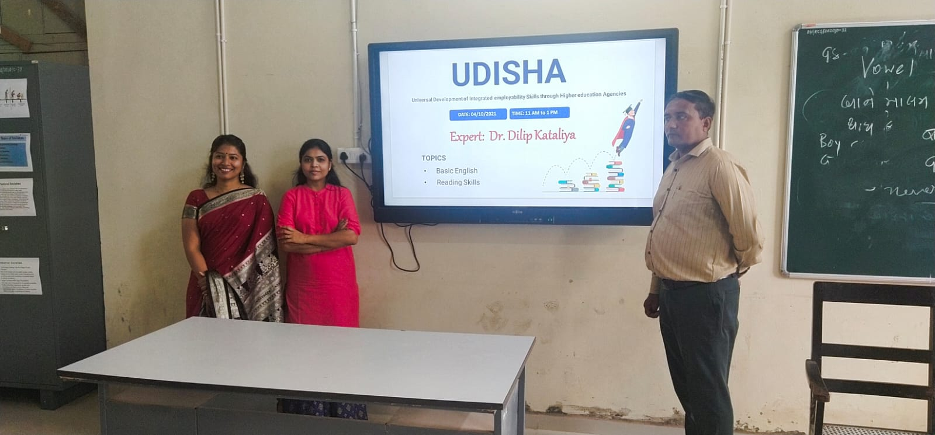

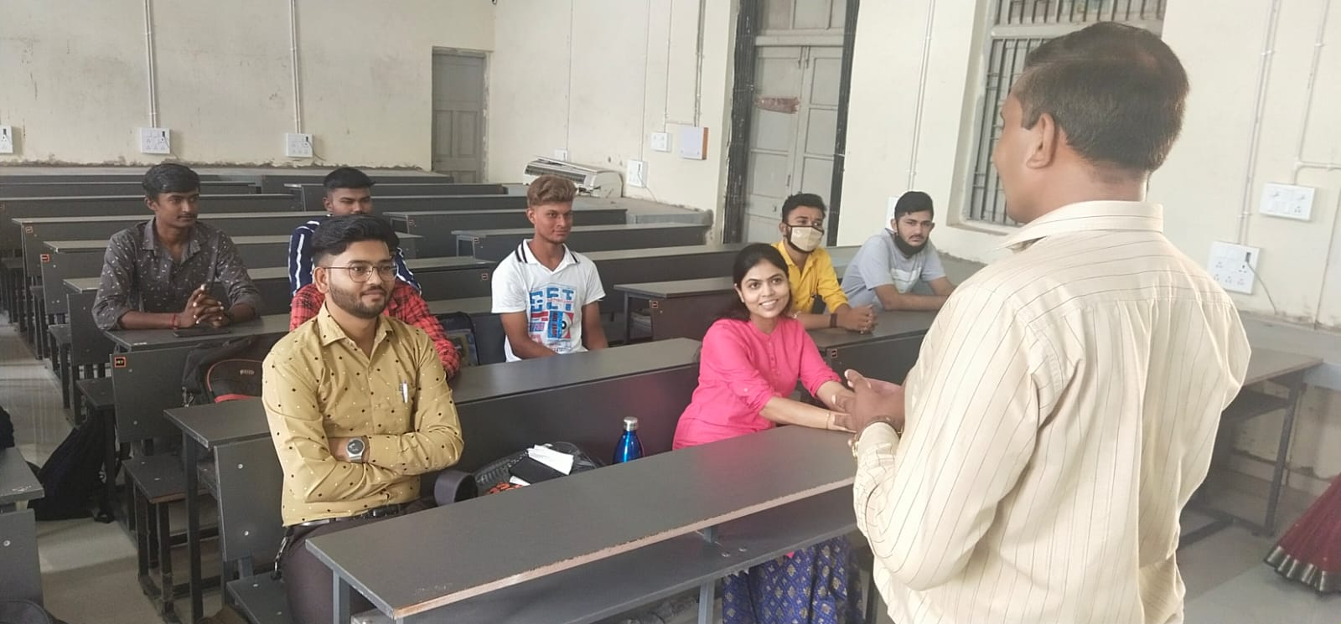

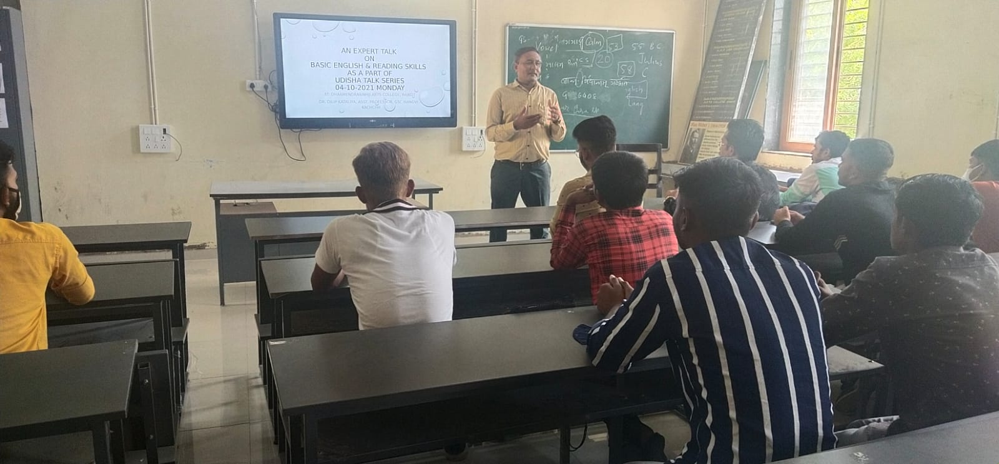

Expert Talk 9
Dr. Sonal Lakhani (09/10/2021)
Topics: Positive Attitude & Interpersonal Skills

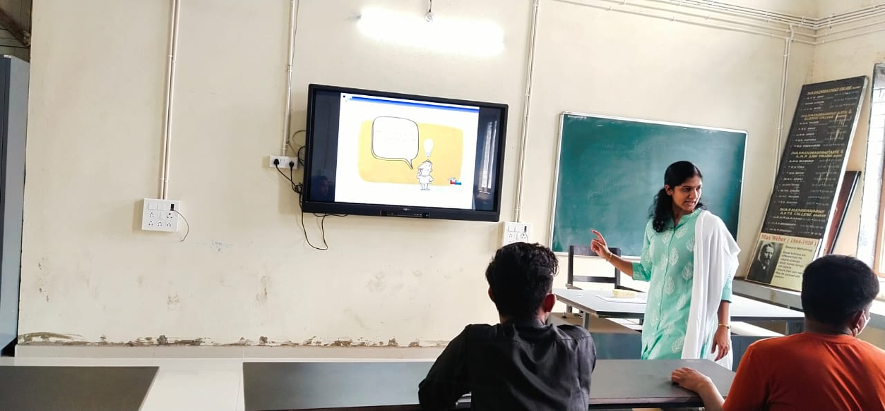

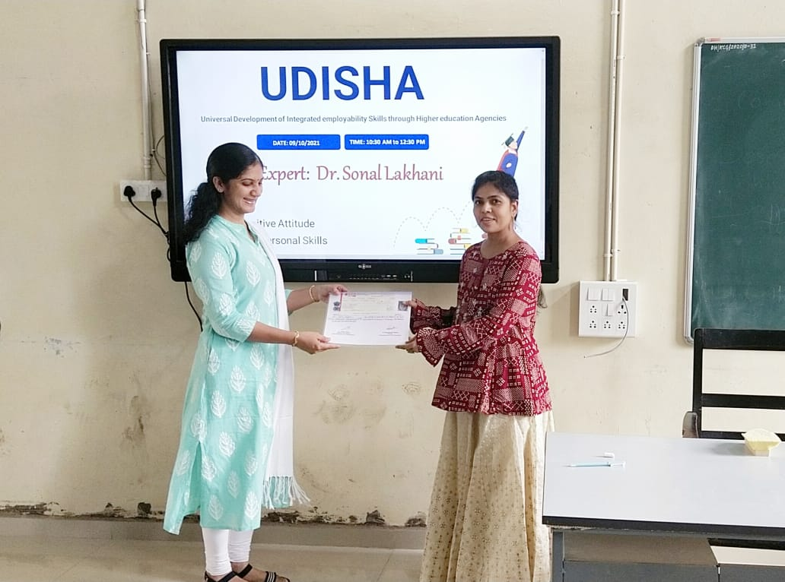
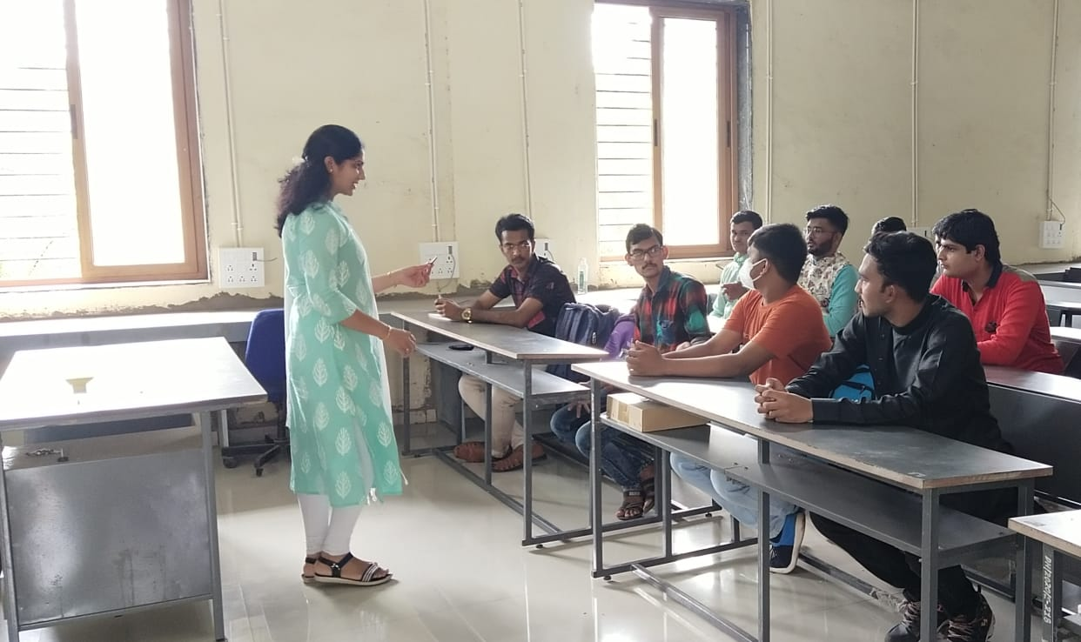

Expert Talk 10
Ms. Divya Panchotia (16/10/2021)
Topics: Positive Attitude & Interpersonal Skills
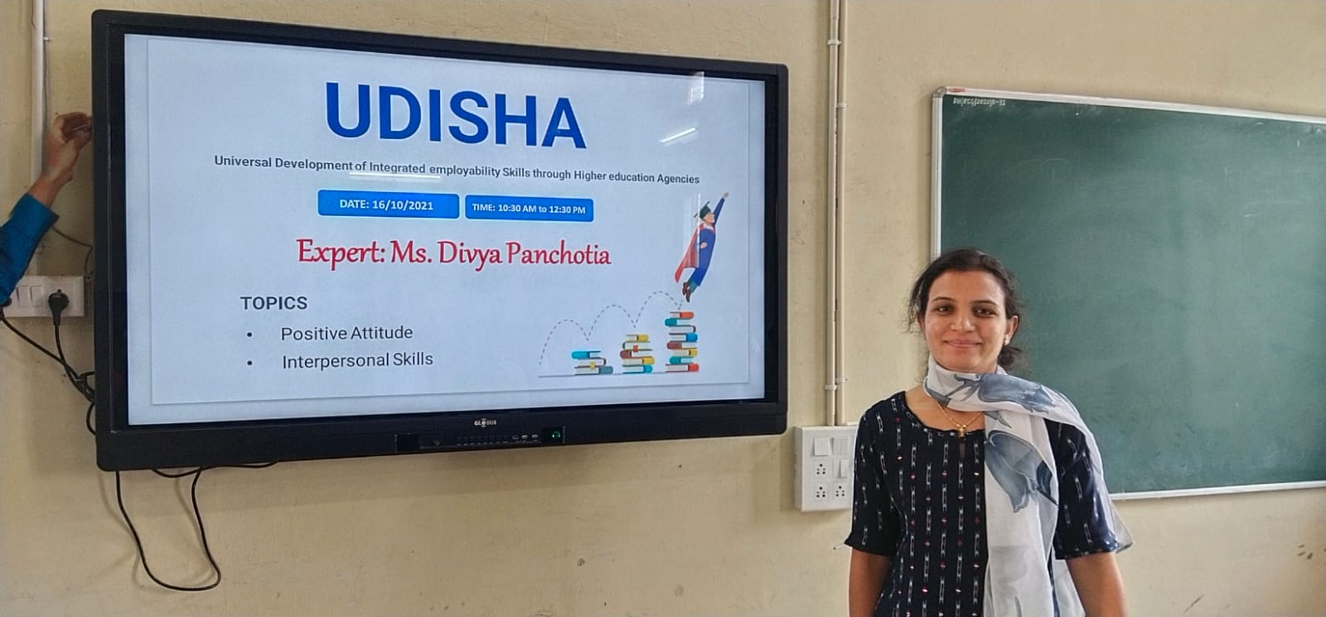

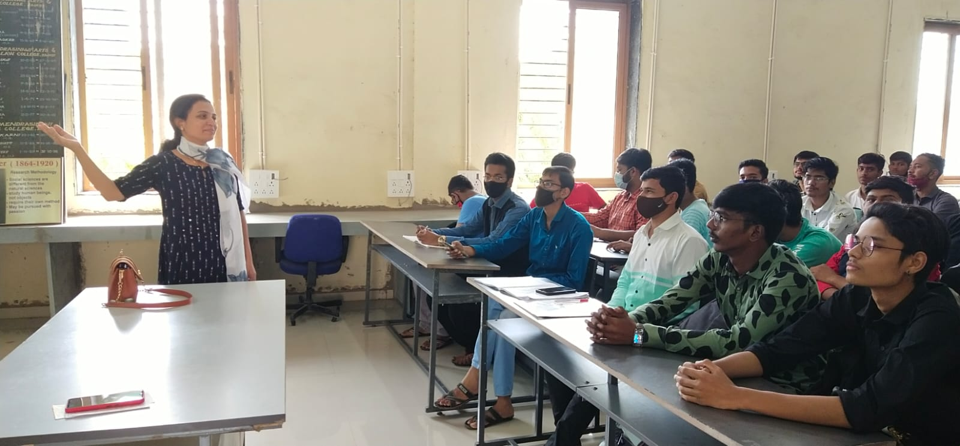
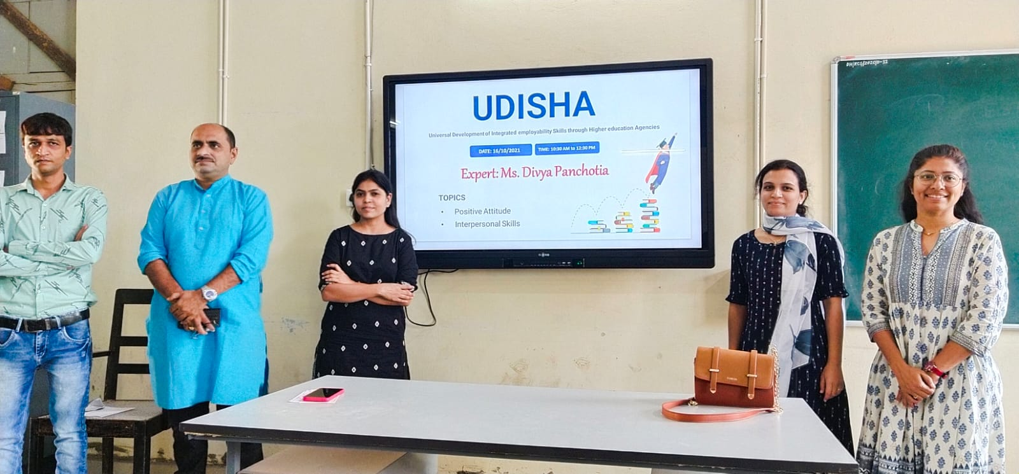

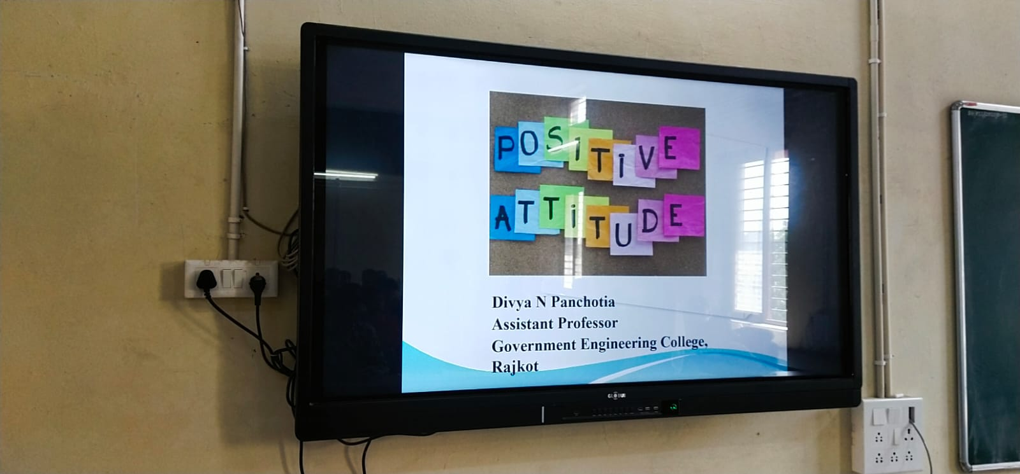

Expert Talk 11
Mr. Sandeep Dave (09/02/2022)
Topics: CV Writing & Interview Skills

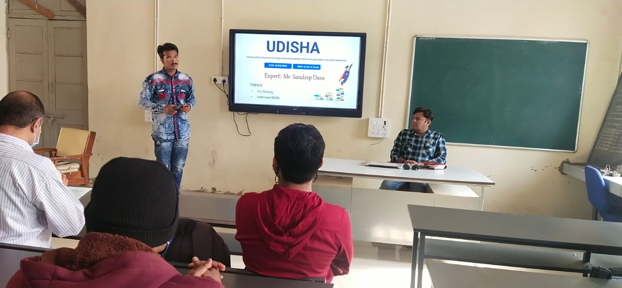

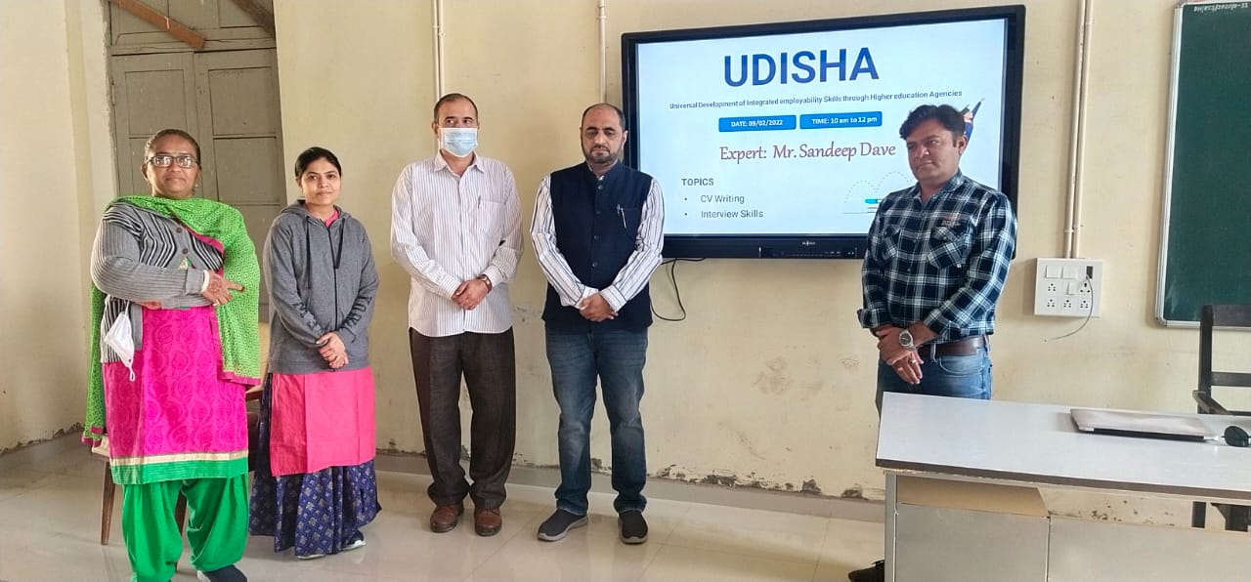

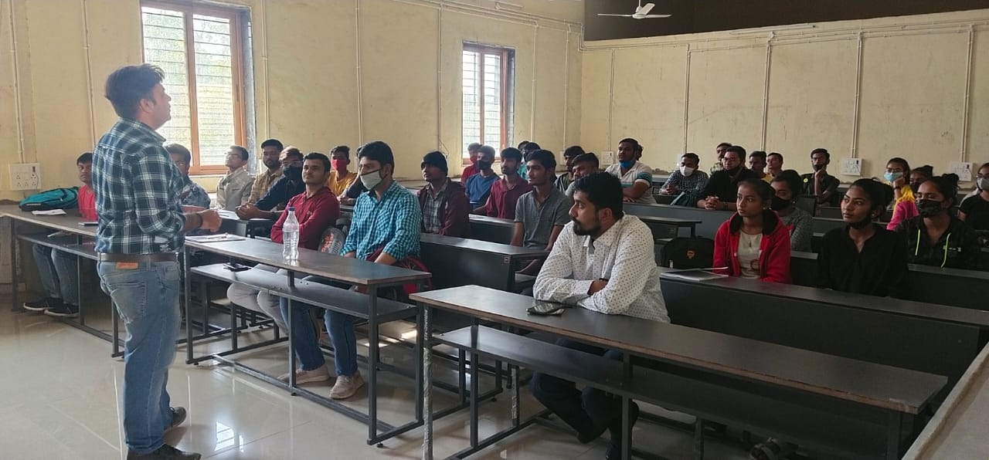

Expert Talk 12
Mr. Malay Solanki (11/02/2022)
Topics: Interpersonal Skills & Interview Skills

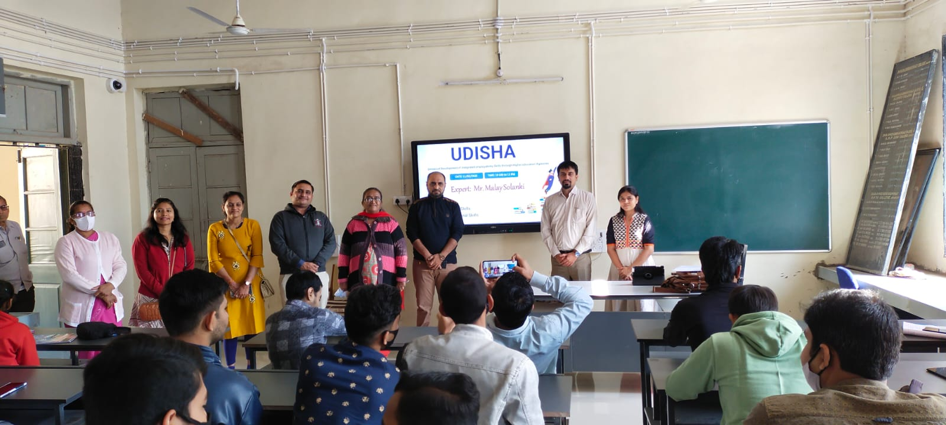

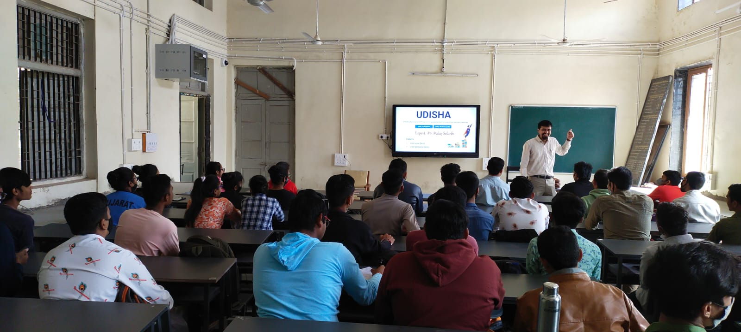

Expert Talk 13
Dr. Shivani Upadhyay (16/02/2022)
Topics: Basic English & Reading Skills

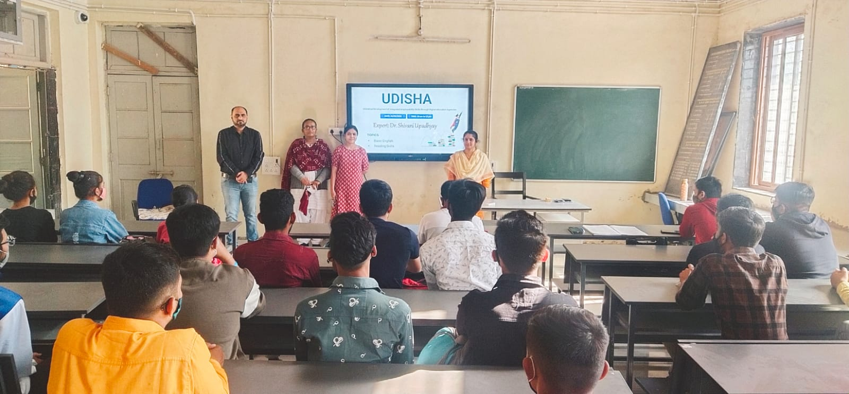

Expert Talk 14
Dr. Bhavdip Chavda (19/02/2022)
Topics: Basic English & Reading Skills

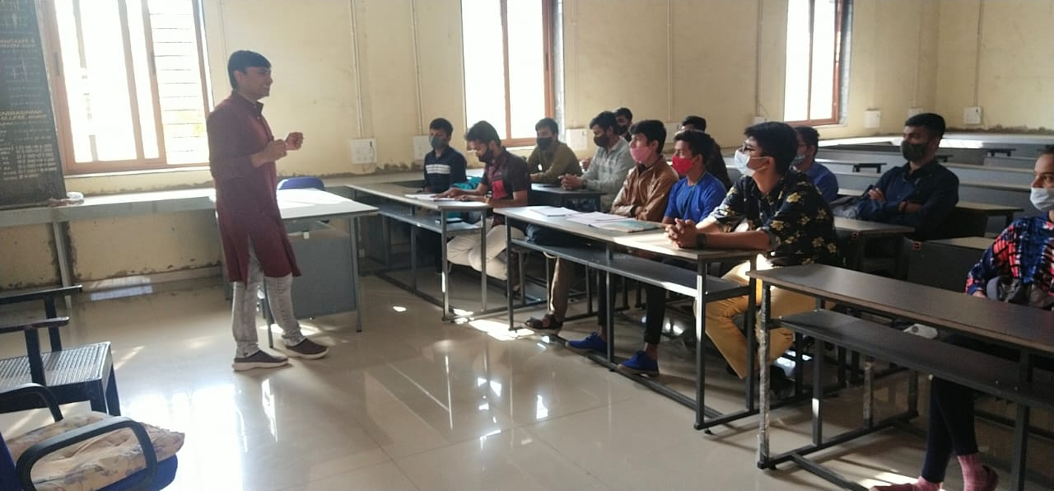

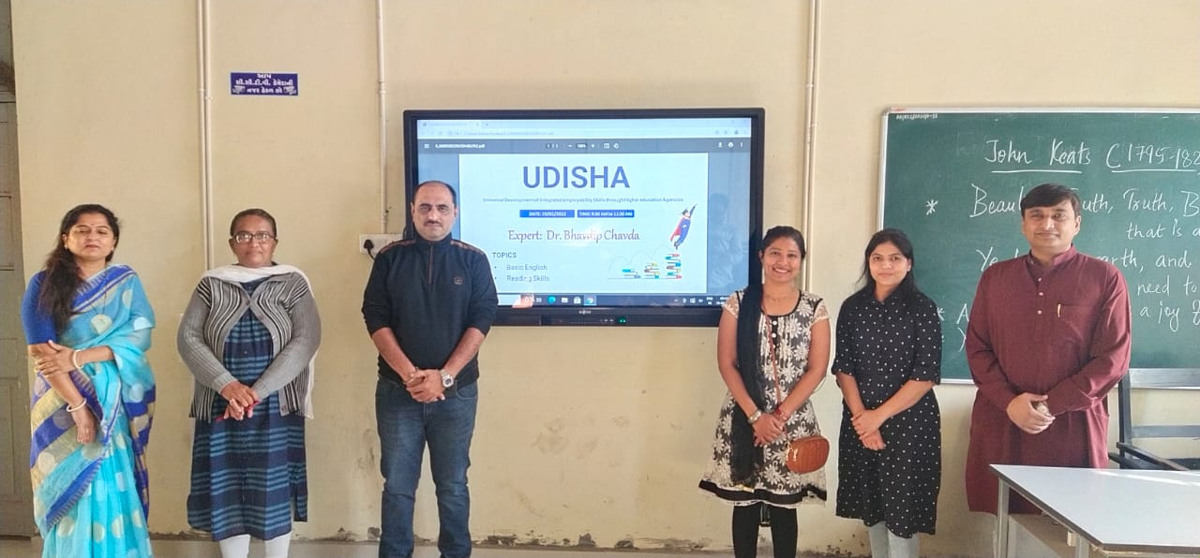
Expert Talk 15
Dr. Smita Gadhvi (07/03/2022)
Topics: Basic English & Interview Skills

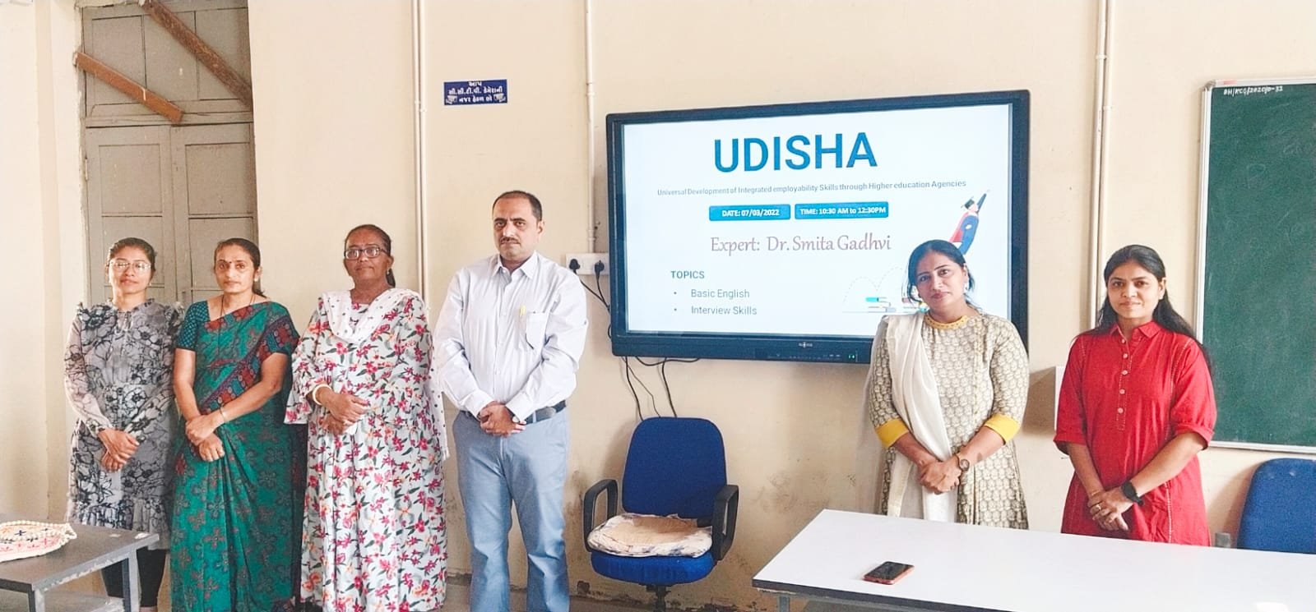

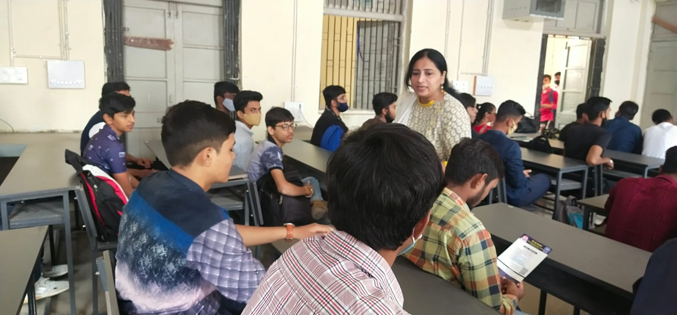

EXPENDITURE

SR.NO. | PARTICULAR | AMOUNT
1 | 30 LECTURES * 750/- | 3 Rs. 22550
2 | Remaining Amount | Rs. 10500
TOTAL |  | Rs. 33000

TOTAL AMOUNT GRANTED FOR UDISHA: 50,000
GRANT ALLOTTED FOR CAMPUS PLACEMENT AND JOB FAIR: Rs. 17,000
AMOUNT SECTIONED FOR LECTURES AND BOOKS:
Rs. 50,000 –Rs. 17,000 = Rs. 33,000
TOTAL EXPENDINTURE: Rs. 22550
REAMINING AMOUNT: Rs. 10500
REAMINING PLACEMENT AMOUNT: Rs. 17000

